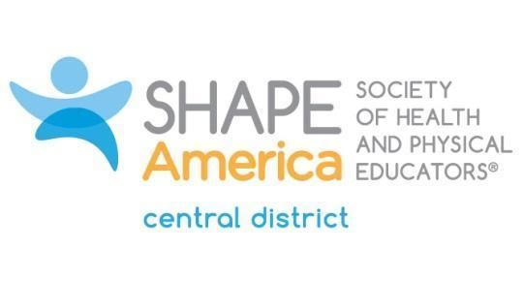

Central District Honor Award Application
To be considered for an award, this official form must be completed in detail.
Resumes or vitae will not be accepted.
A head-and-shoulders picture must be sent with the nomination.
A statement from one sponsor explaining the merit of the nominee's contributions must accompany this application.
SPONSOR
First Name:
Last Name:
Mailing Address:
Phone (H):
Phone (W):
Email:
PERSONAL DATA OF NOMINEE
First Name:
Last Name:
Mailing Address:
Phone (H):
Phone (W):
Email:
SHAPE America Membership #:
# of Years as SHAPE America Member:

EMPLOYMENT HISTORY
Present Position:
Previous Positions:
EDUCATION Institution Degree Date
High School:
Undergraduate:
Graduate:

Please provide information to complete the following requirements* and to present your contributions to
the profession. Use no more than five typed pages, including the cover sheet. If more pages are submitted, the Recognition Awards Committee will use only the first five. Thank you.

*You must:
- Be a member of SHAPE America for a minimum of eight years (postgraduate academic degrees are not a prerequisite qualification)
- Have at least 10 years of full-time professional experience as a teacher, supervisor or administrator, or a combination of the same in the fields of health, physical education, recreation and/or dance
- Currently reside or be employed in Central District
- Have been active in Central District for a minimum of three years as a district officer, committee member, liaison to a SHAPE America committee and/or have three or more years of district committee work

Other factors to be considered are:
- Distinctive leadership and/or long-term service to SHAPE America or other national associations
- Distinctive leadership and/or long-term service to the state association
- Presentations before educational groups, at conventions, assemblies and luncheon meetings held in the interest and promotion of health, physical education, recreation and/or dance
- Systematic research or grantsmanship, which has helped to advance the profession
- Author or co-author of one or more books on health, physical education, recreation or dance
- Promotion of outstanding programs in any area of health, physical education, recreation or dance at any educational level

SHAPE America Offices Held:
District:
State:
National:

SHAPE America Committee Work:
District:
State:
National:

Professional Contributions such as:
Speeches and presentations:
Writing and research:
Choreography and creative activity:

Other Professional Educational Endeavors:
Community Relationships and Services:
Honors Received:
Email the Honor Award application and photograph, along with a letter from the sponsor, to:
Deb Stephenson: stephensond@sw1.k12.wy.us
Application Deadline: October 15

